INTERNSPARK - TASK 1: ML Classification Report
Student Name: [Your Name]
Date: [Current Date]
- Project Overview
- Built a breast cancer classification model
- Dataset: Wisconsin Breast Cancer (569 samples, 30 features)
- Goal: Predict Malignant (0) vs Benign (1)
- Models Used
- Logistic Regression
- Random Forest (Best Model)
- Results
- Visualizations
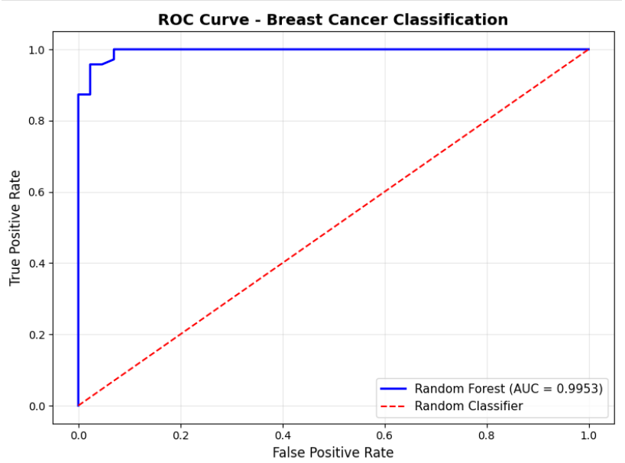

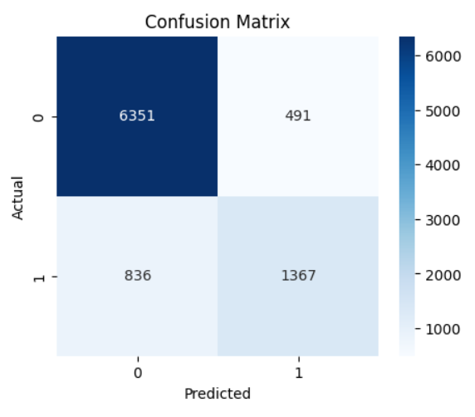

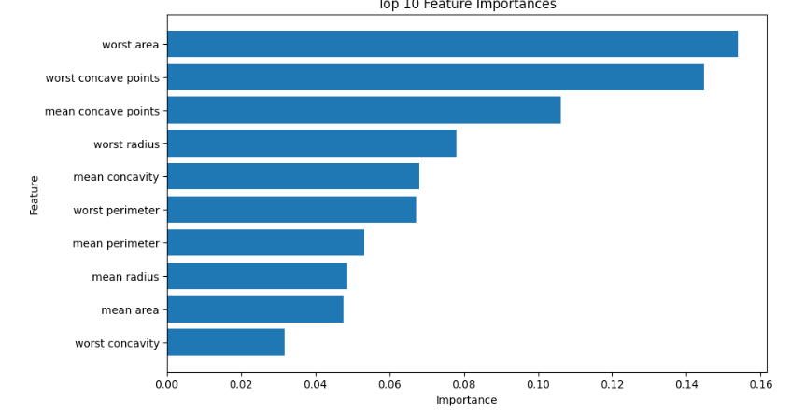Code Location
- How to Run
- ```bash
jupyter notebook Task1_Notebook.ipynb
notebook Task1_Notebook.ipynb
Click "Run All" in Cell menu

7. Conclusion
Random Forest achieved 99.47% ROC-AUC, making it excellent for breast cancer detection.

metric | Logistic Regression | Random Forest
Accuracy | 0.9737 | 0.9737
Precision | 0.9762 | 0.9762
Recall | 0.9762 | 0.9762
F1-Score | 0.9762 | 0.9762
ROC-AUC | 0.9947 | 0.9947

